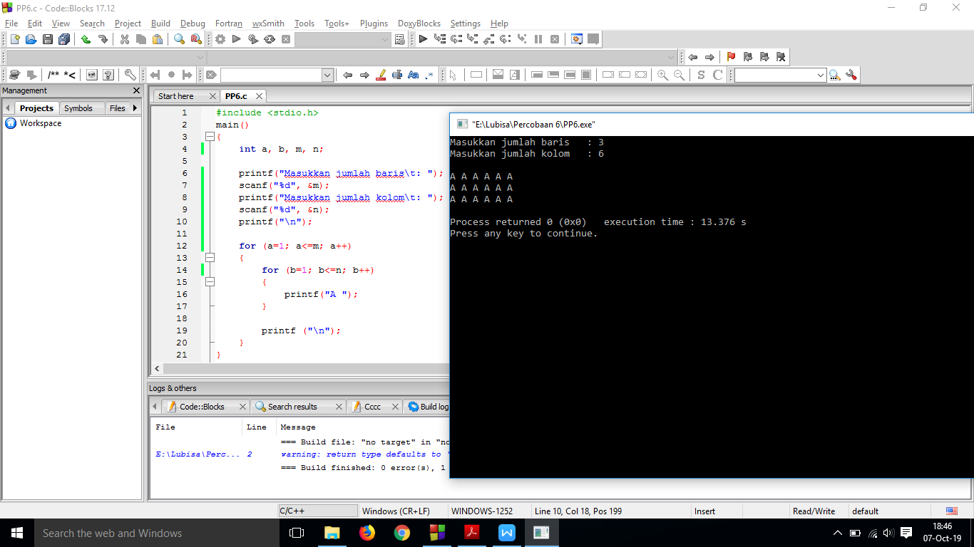

#include <stdio.h>

main()

{

int a, b, m, n;

printf("Masukkan jumlah baris\t: ");

scanf("%d", &m);

printf("Masukkan jumlah kolom\t: ");

scanf("%d", &n);

printf("\n");

for (a=1; a<=m; a++)

{

for (b=1; b<=n; b++)

{

printf("A ");

}

printf ("\n");

}

}

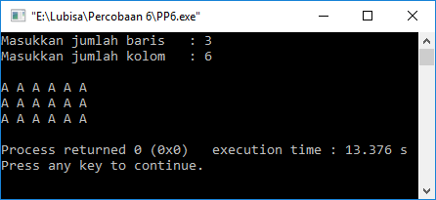

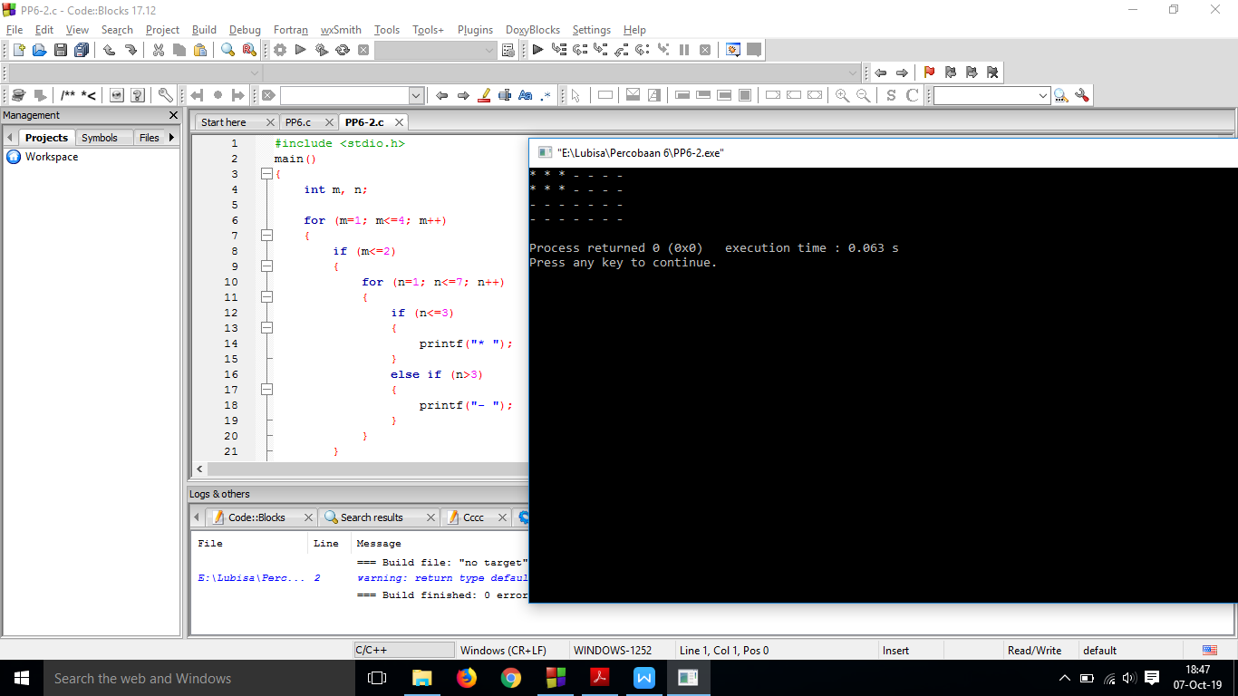

#include <stdio.h>

main()

{

int m, n;

for (m=1; m<=4; m++)

{

if (m<=2)

{

for (n=1; n<=7; n++)

{

if (n<=3)

{

printf("\* ");

}

else if (n>3)

{

printf("- ");

}

}

}

else if (m>2)

{

for (n=1; n<=7; n++)

{

printf("- ");

}

}

printf("\n");

}

}

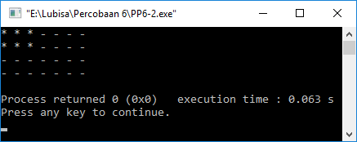

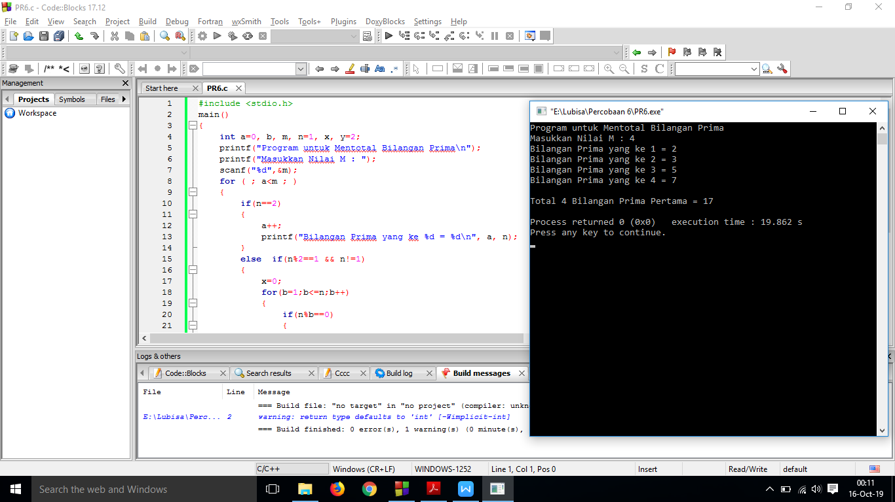

#include <stdio.h>

main()

{

int a=0, b, m, n=1, x, y=2;

printf("Program untuk Mentotal Bilangan Prima\n");

printf("Masukkan Nilai M : ");

scanf("%d",&m);

for ( ; a<m ; )

{

if(n==2)

{

a++;

printf("Bilangan Prima yang ke %d = %d\n", a, n);

}

else if(n%2==1 && n!=1)

{

x=0;

for(b=1;b<=n;b++)

{

if(n%b==0)

{

x++;

}

}

if(x==2)

{

a++;

printf("Bilangan Prima yang ke %d = %d\n", a, n);

y+=n;

}

}

n++;

}

printf("\nTotal %d Bilangan Prima Pertama = %d\n", a, y);

}

